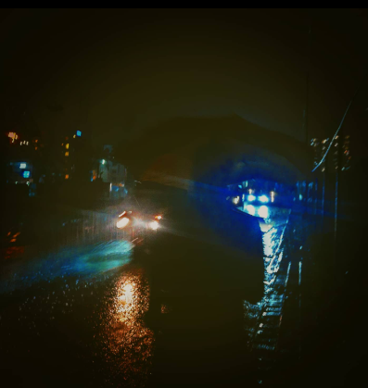

To walk along a dimly lit street,
drenched in rain, drenched in pain,
drenched in blood not visible,
drenched in thoughts, wishing
never to be seen again,

the street diverges into two,
and to take one,
a decision has to be made,
to choose to be seen,
or choose to just fade,
to be just black and white,
or to accept all the shades,
to be and bear,
to not be,
and get erased,

to walk along a street,
which for a conscious being,
was never made,
Regardless of the choice,
there is no real win,
you get some of what you want,
and the rest just slips,
and in the acceptance ,
of all the imperfect things,

do we find peace,
do we rest at ease,
does the pain cease,
the soul is freed,
of itself and what it sees,
we leave the street,
we leave the street,
we live the street.

